Minesweeper Generator

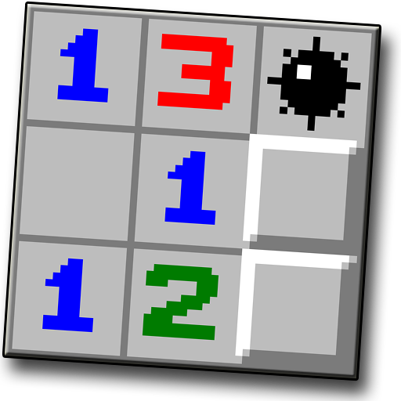
Everybody remembers the old mines game. Now it is time to create your own.

You will be given an integer n for the size of the mines field with square shape and another one for the number of bombs that you have to place in the field. On the next n lines, you will receive the position for each bomb. Your task is to create the game field placing the bombs at the correct positions and mark them with "*", and calculate the numbers in each cell of the field. Each cell represents a number of all bombs directly near it (up, down, left, right and the 4 diagonals).

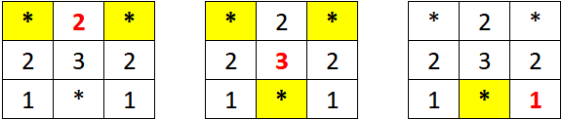

Input
- On the first line, you are given the integer n – the size of the square matrix.
- On the second line – the number of the bombs.
- The next n lines holds the position of each bomb.

Output
- Print the matrix you've created.

Constraints
- The size of the square matrix will be between [2…15].

Examples
Input | Output
4  4  (0, 3)  (1, 1)  (2, 2)  (3, 0) | 1 1 2 *  1 * 3 2  2 3 * 1  * 2 1 1
5  3  (1, 1)  (2, 4)  (4, 1) | 1 1 1 0 0  1 * 1 1 1  1 1 1 1 *  1 1 1 1 1  1 * 1 0 0

