Problem 2 – String Matrix Rotation
You are given a sequence of text lines. Assume these text lines form a matrix of characters (pad the missing positions with spaces to build a rectangular matrix). Write a program to rotate the matrix by 90, 180, 270, 360, … degrees. Print the result at the console as sequence of strings. Examples:
Input | Rotate(90) | Rotate(180) | Rotate(270)
hello  softuni  exam | 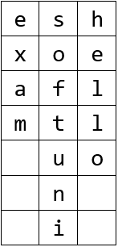 | 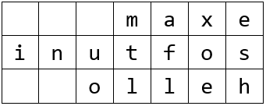 | 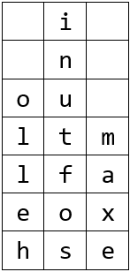
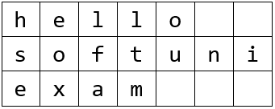

Input
The input is read from the console:
- The first line holds a command in format "Rotate(X)" where X are the degrees of the requested rotation.
- The next lines contain the lines of the matrix for rotation.
- The input ends with the command "END".
The input data will always be valid and in the format described. There is no need to check it explicitly.

Output
Print at the console the rotated matrix as a sequence of text lines.

Constraints
- The rotation degrees is positive integer in the range [0…90000], where degrees is multiple of 90.
- The number of matrix lines is in the range [1…1 000].
- The matrix lines are strings of length 1 … 1 000.
- Allowed working time: 0.2 seconds. Allowed memory: 16 MB.

Examples
Input | Output |  | Input | Output |  | Input | Output
Rotate(90)  hello  softuni  exam | esh  xoe  afl  mtl  uo  n  i |  | Rotate(180)  hello  softuni  exam | maxe  inutfos  olleh |  | Rotate(270)  hello  softuni  exam | i  n  ou  ltm  lfa  eox  hse

Input | Output |  | Input | Output |  | Input | Output
Rotate(720)  js  exam | js  exam |  | Rotate(810)  js  exam | ej  xs  a  m |  | Rotate(0)  js  exam | js  exam

