Lab: Linear Data Structures
This document defines the in-class exercises assignments the "Data Structures" course @ Software University. You can submit your code in the SoftUni Judge System - https://judge.softuni.bg/Contests/574/Linear-Data-Structures-Stacks-and-Queues-Lab.

LinkedList<T>
Implement a data structure LinekdList<T> that holds a sequence of elements of generic type T. It should hold a sequence of items in a sequence of linked nodes. The list should support the following operations:
- int Count returns the number of elements in the structure
- void AddFirst(T item) adds an element to the start of the sequence
- void AddLast(T item) adds an element to the end of the sequence
- T RemoveFirst() removes an element from the start of the sequence and returns the element
- T RemoveLast() removes an element from the end of the sequence and returns the element
- IEnumerable<T> implement interface
RemoveFirst() and RemoveLast() methods should throw InvalidOperationException if the list is empty

Examples
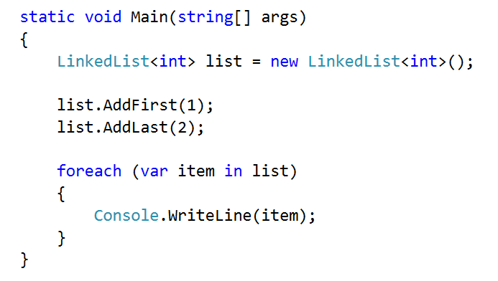

Solution
Start by defining the class LinkedList<T>, you can define the Node class inside (in which case it doesn't need to be generic, as you will use T from the LinkedList)
Also, note that we are going to keep a reference to both the head and the tail of the list
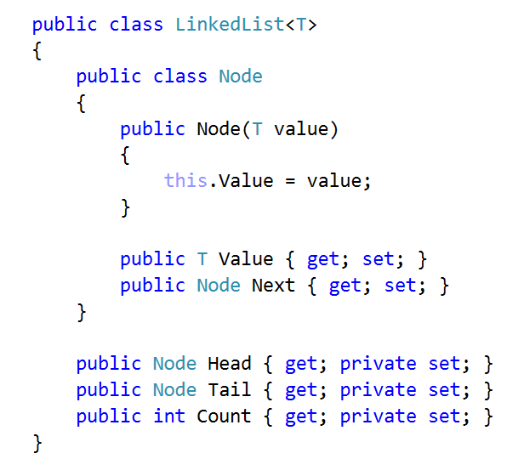
First, implement AddFirst(). The utility method IsEmpty() checks if the Count is 0
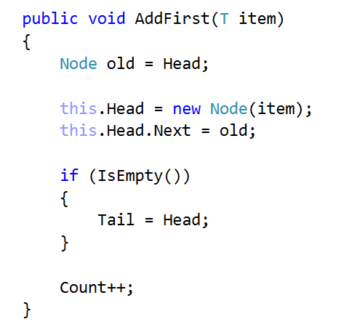
AddLast() is almost the same
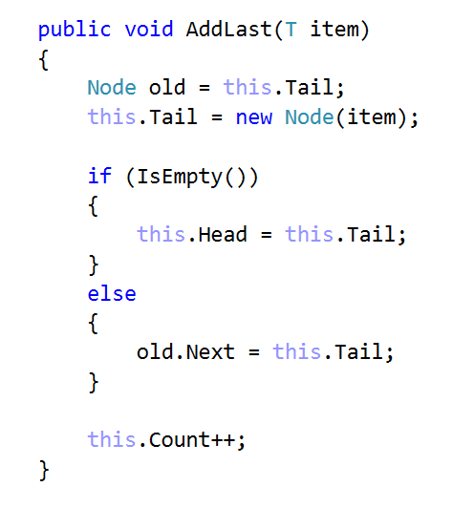
Remove methods are a little bit more complicated. Start with RemoveFirst()
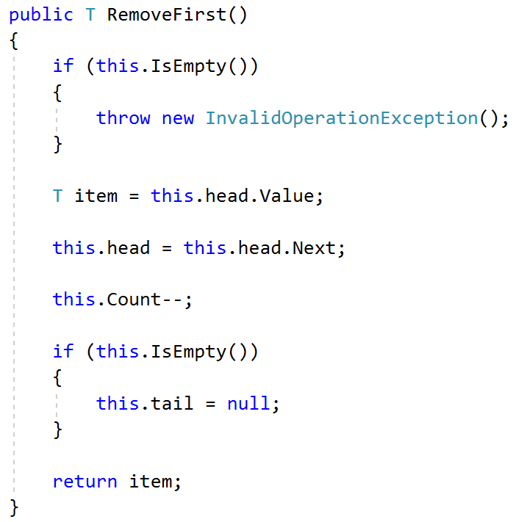
Method RemoveLast() uses a utility method GetSecondToLast() which gets the second to last element. Try to implement it yourself
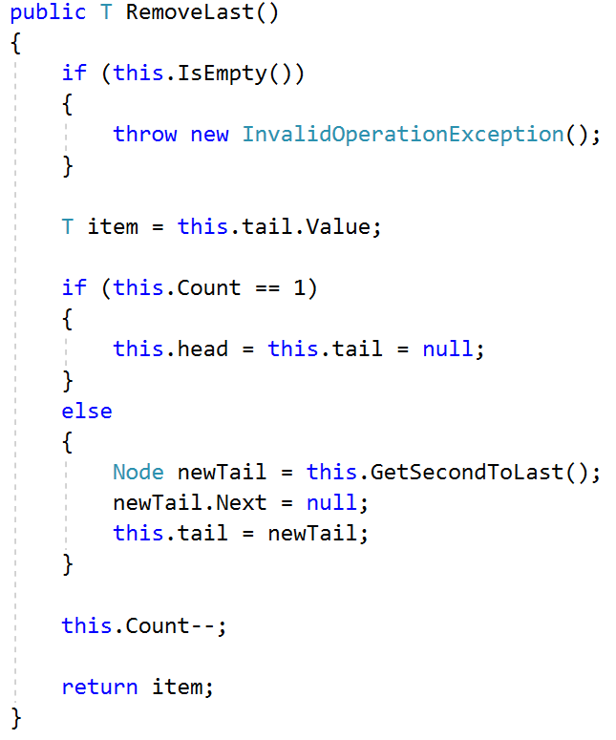
The last thing to do is to implement IEnumerable<T>
You need to implement two methods. The first is the actual that will do the work. The second one calls the first and you need it only for compatibility reasons
