Exercises: Arrays
You can check your solutions here: https://judge.softuni.bg/Contests/Compete/Index/867#0.
- Day of Week
Enter a day number [1…7] and print the day name (in English) or “Invalid Day!”. Use an array of strings.
Examples
Input | Output
1 | Monday
2 | Tuesday
7 | Sunday
0 | Invalid Day!
Hints
- Use an array of strings holding the day names: {"Monday", "Tuesday", "Wednesday", "Thursday", "Friday", "Saturday", "Sunday"}.
- Print the element at index (day-1) when it is in the range [1…7] or “Invalid Day!” otherwise.
- Reverse an Array of Integers
Write a program to read an array of integers, reverse it and print its elements. The input consists of a number n (the number of elements) + n integers, each as a separate line. Print the output on a single line (space separated).
Examples
Input | Output
3  10  20  30 | 30 20 10
4  -1  20  99  5 | 5 99 20 -1
Hints
- First, read the number n.
- Allocate an array of n integers.
- Read the integers in a for-loop.
- Instead of reversing the array, you can just pass through the elements from the last (n-1) to the first (0) with a reverse for-loop.
- Triple Sum
Write a program to read an array of integers and find all triples of elements a, b and c, such that a + b == c (where a stays to the left from b). Print “No” if no such triples exist.
Examples
Input | Output
1 1 1 1 | No
4 2 8 6 | 4 + 2 == 6  2 + 6 == 8
2 7 5 0 | 2 + 5 == 7  2 + 0 == 2  7 + 0 == 7  5 + 0 == 5
3 1 5 6 1 2 | 3 + 2 == 5  1 + 5 == 6  1 + 1 == 2  1 + 2 == 3  5 + 1 == 6  1 + 2 == 3
Hints:
- Read the input numbers in array arr[].
- Use nested loops to generate all pairs {a, b}, such that 0 ≤ a < b < n.
- Check whether arr[] contains the sum arr[a] + arr[b].
- Sum Arrays
Write a program that reads two arrays of integers and sums them. When the arrays are not of the same size, duplicate the smaller array a few times.
Examples
Input | Output | Comments
1 2 3 4  2 3 4 5 | 3 5 7 9 | 1 2 3 4 +  2 3 4 5 =  3 5 7 9
1 2 3 4 5  2 3 | 3 5 5 7 7 | 1 2 3 4 5 +  2 3 2 3 2 =  3 5 5 7 7
5 4 3  2 3 1 4 | 7 7 4 9 | 5 4 3 5 +  2 3 1 4 +  7 7 4 9
Hints
- Assume the first array arr1 has len1 elements and the second arr2 has len2 elements.
- The result array will have max(len1, len2) elements.
- We sum array elements one by one (from the first to the last). To enable rotating (take the first element as next after the last), we use the position % length indexing: arr1[i % len1] and arr2[i % len2].
- Condense Array to Number
Write a program to read an array of integers and condense them by summing adjacent couples of elements until a single integer is obtained. For example, if we have 3 elements {2, 10, 3}, we sum the first two and the second two elements and obtain {2+10, 10+3} = {12, 13}, then we sum again all adjacent elements and obtain {12+13} = {25}.
Examples
Input | Output | Comments
2 10 3 | 25 | 2 10 3 2+10 10+3 12 13 12 + 13 25
5 0 4 1 2 | 35 | 5 0 4 1 2 5+0 0+4 4+1 1+2 5 4 5 3 5+4 4+5 5+3 9 9 8 9+9 9+8 18 17 18+17 35
1 | 1 | 1 is already condensed to number
Hints
While we have more than one element in the array nums[], repeat the following:
- Allocate a new array condensed[] of size nums.Length-1.
- Sum the numbers from nums[] to condensed[]:
- condensed[i] = nums[i] + nums[i+1]
- nums[] = condensed[]
The process is illustrated below:
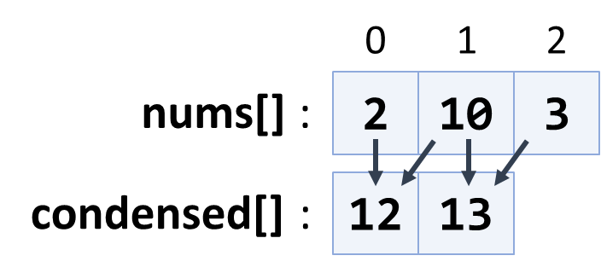
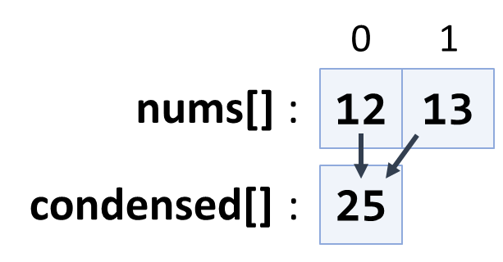
- Extract Middle 1, 2 or 3 Elements
Write a method to extract the middle 1, 2 or 3 elements from array of n integers and print them.
- n = 1 -> 1 element
- even n -> 2 elements
- odd n -> 3 elements
Create a program that reads an array of integers (space separated values) and prints the middle elements in the format shown in the examples.
Examples
Input | Output
5 | { 5 }
2 3 8 1 7 4 | { 8, 1 }
1 2 3 4 5 6 7 | { 3, 4, 5 }
10 20 30 40 50 60 70 80 | { 40, 50 }
Hints
- Write different logic for each case (n = 1, even n, odd n)
- n = 1 take the first element
- odd n take elements n/2-1, n/2, n/2+1
- even n take elements n/2-1 and n/2
- Last K Numbers Sums Sequence
Enter two integers n and k. Generate and print the following sequence of n elements:
- The first element is: 1
- All other elements = sum of the previous k elements (if less than k are available, sum all of them)
- Example: n = 9, k = 5 120 = 1 + 1 + 2 + 4 + 8 + 16 + 31 + 61
Examples
Input | Output
6  3 | 1 1 2 4 7 13
8  2 | 1 1 2 3 5 8 13 21
9  5 | 1 1 2 4 8 16 31 61 120
Hints
- Use an array of integers to hold the sequence.
- Initially seq[0] = 1
- Use two nested loops:
- Loop through all elements i = 1 … n
- Sum the elements i-k … i-1: seq[i] = sum(seq[i-k … i-1])
- Largest Common End
Read two arrays of words and find the length of the largest common end (left or right).
Examples
Input | Output | Comments
hi php java csharp sql html css js  hi php java js softuni nakov java learn | 3 | The largest common end is at the left: hi php java
hi php java xml csharp sql html css js  nakov java sql html css js | 4 | The largest common end is at the right: sql html css js
I love programming  Learn Java or C# | 0 | No common words at the left and right
Hints
- Scan the arrays from left to right until the end of the shorter is reached and count the equal elements.
- Scan the arrays form right to left until the start of the shorter is reached.
- Keep the start position and the length of the longest equal start / end.
- Rotate and Sum
To “rotate an array on the right” means to move its last element first: {1, 2, 3} {3, 1, 2}.
Write a program to read an array of n integers (space separated on a single line) and an integer k, rotate the array right k times and sum the obtained arrays after each rotation as shown below.
Examples
Input | Output | Comments
3 2 4 -1  2 | 3 2 5 6 | rotated1[] = -1 3 2 4  rotated2[] = 4 -1 3 2  sum[] = 3 2 5 6
1 2 3  1 | 4 3 5 | rotated1[] = 3 1 2  sum[] = 4 3 5
1 2 3 4 5  3 | 12 10 8 6 9 | rotated1[] = 5 1 2 3 4  rotated2[] = 4 5 1 2 3  rotated3[] = 3 4 5 1 2  sum[] = 12 10 8 6 9
Hints
- After r rotations the element at position i goes to position (i + r) % n.
- The sum[] array can be calculated by two nested loops: for r = 1 … k; for i = 0 … n-1.
- Fold and Sum
Read an array of 4*k integers, fold it like shown below, and print the sum of the upper and lower two rows (each holding 2 * k integers):
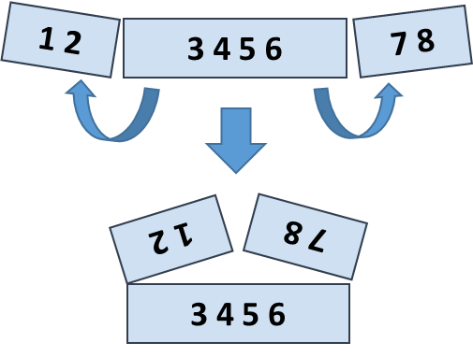
Examples
Input | Output | Comments
5 2 3 6 | 7 9 | 5 6 +  2 3 =  7 9
1 2 3 4 5 6 7 8 | 5 5 13 13 | 2 1 8 7 +  3 4 5 6 =  5 5 13 13
4 3 -1 2 5 0 1 9 8 6 7 -2 | 1 8 4 -1 16 14 | -1 3 4 -2 7 6 +  2 5 0 1 9 8 =  1 8 4 -1 16 14
Hints
- Create the first row after folding: the first k numbers reversed, followed by the last k numbers reversed.
- Create the second row after folding: the middle 2*k numbers.
- Sum the first and the second rows.
- Compare Char Arrays
Compare two char arrays lexicographically (letter by letter).
Print the them in alphabetical order, each on separate line.
Examples
Input | Output
a b c  d e f | abc  def
p e t e r  a n n i e | annie  peter
a n n i e  a n | an  annie
a b  a b | ab  ab
Hints
- Compare the first letter of arr1[] and arr2[], if equal, compare the next letter, etc.
- If all letters are equal, the smaller array is the shorter.
- If all letters are equal and the array lengths are the same, the arrays are equal.
- Max Sequence of Equal Elements
Write a program that finds the longest sequence of equal elements in an array of integers. If several longest sequences exist, print the leftmost one.
Examples
Input | Output
2 1 1 2 3 3 2 2 2 1 | 2 2 2
1 1 1 2 3 1 3 3 | 1 1 1
4 4 4 4 | 4 4 4 4
0 1 1 5 2 2 6 3 3 | 1 1
Hints
- Start with the sequence that consists of the first element: start=0, len=1.
- Scan the elements from left to right, starting at the second element: pos=1…n-1.
- At each step compare the current element with the element on the left.
- Same value you have found a sequence longer by one len++.
- Different value start a new sequence from the current element: start=pos, len=1.
- After each step remember the sequence it is found to be longest at the moment: bestStart=start, bestLen=len.
- Finally, print the longest sequence by using bestStart and bestLen.
- Max Sequence of Increasing Elements
Write a program that finds the longest increasing subsequence in an array of integers. The longest increasing subsequence is a portion of the array (subsequence) that is strongly increasing and has the longest possible length. If several such subsequences exist, find the left most of them.
Examples
Input | Output
3 2 3 4 2 2 4 | 2 3 4
4 5 1 2 3 4 5 | 1 2 3 4 5
3 4 5 6 | 3 4 5 6
0 1 1 2 2 3 3 | 0 1
Hints
- Use the same algorithm like in the previous problem (Max Sequence of Equal Elements).
- Most Frequent Number
Write a program that finds the most frequent number in a given sequence of numbers.
- Numbers will be in the range [0…65535].
- In case of multiple numbers with the same maximal frequency, print the left most of them.
Examples
Input | Output | Output
4 1 1 4 2 3 4 4 1 2 4 9 3 | 4 | The number 4 is the most frequent (occurs 5 times)
2 2 2 2 1 2 2 2 | 2 | The number 2 is the most frequent (occurs 7 times)
7 7 7 0 2 2 2 0 10 10 10 | 7 | The numbers 2, 7 and 10 have the same maximal frequence (each occurs 3 times). The leftmost of them is 7.
- Index of Letters
Write a program that creates an array containing all letters from the alphabet (a-z). Read a lowercase word from the console and print the index of each of its letters in the letters array.
Examples
Input | Output
abcz | a -> 0  b -> 1  c -> 2  z -> 25
softuni | s -> 18  o -> 14  f -> 5  t -> 19  u -> 20  n -> 13  i -> 8
- Pairs by Difference
Write a program that count the number of pairs in given array which difference is equal to given number.
Input
- The first line holds the sequence of numbers.
- The second line holds the difference.
Examples
Input | Output | Comments
1 5 3 4 2  2 | 3 | Pairs of elements with difference 2 -> {1, 3}, {5, 3}, {4, 2}
5 3 8 10 12 1  1 | 0 | No pairs with difference 1
- Equal Sums
Write a program that determines if there exists an element in the array such that the sum of the elements on its left is equal to the sum of the elements on its right. If there are no elements to the left / right, their sum is considered to be 0. Print the index that satisfies the required condition or “no” if there is no such index.
Examples
Input | Output | Comments
1 2 3 3 | 2 | At a[2] -> left sum = 3, right sum = 3  a[0] + a[1] = a[3]
1 2 | no | At a[0] -> left sum = 0, right sum = 2  At a[1] -> left sum = 1, right sum = 0  No such index exists
1 | 0 | At a[0] -> left sum = 0, right sum = 0
1 2 3 | no | No such index exists
10 5 5 99 3 4 2 5 1 1 4 | 3 | At a[3] -> left sum = 20, right sum = 20  a[0] + a[1] + a[2] = a[4] + a[5] + a[6] + a[7] + a[8] + a[9] + a[10]

